**EXPERIMENT NO. 05**

**Program for Addition :** AddI.java

import java.rmi.Remote;

public interface AddI extends Remote{

public int add(int x, int y) throws Exception;

}

**AddC.java :**

import java.rmi.server.*;

public class AddC extends UnicastRemoteObject implements AddI{

public AddC() throws Exception

{

super();

}

public int add (int x, int y)

{

return x+y;

}

}

**Client.java :**

import java.rmi.*;

public class Client{

public static void main(String args[]) throws Exception

{

AddI obj=(AddI)Naming.lookup("ADD");

int n=obj.add(23,20);

System.out.println("Addition is : "+n);

}

}

**Server.java :**

import java.rmi.*;

public class Server{

public static void main(String args[]) throws Exception

{

AddC obj = new AddC();

Naming.rebind("ADD",obj);

System.out.println("Server Started");

}

}

**OUTPUT**

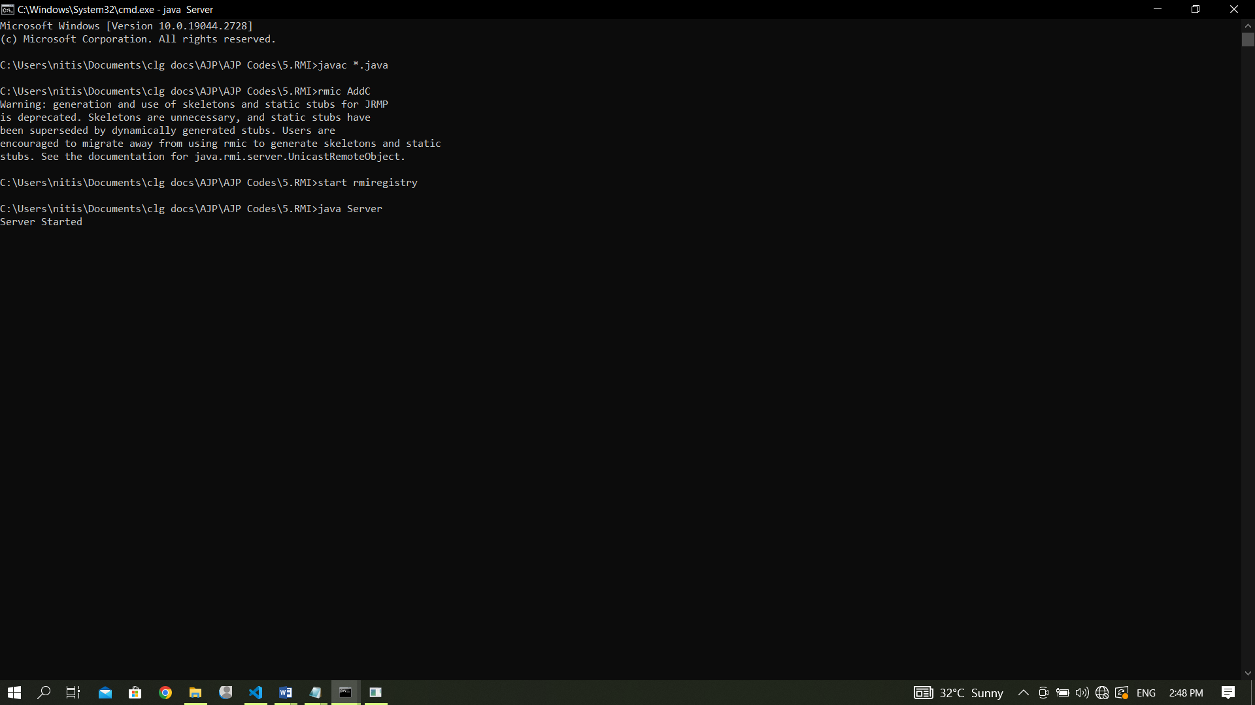

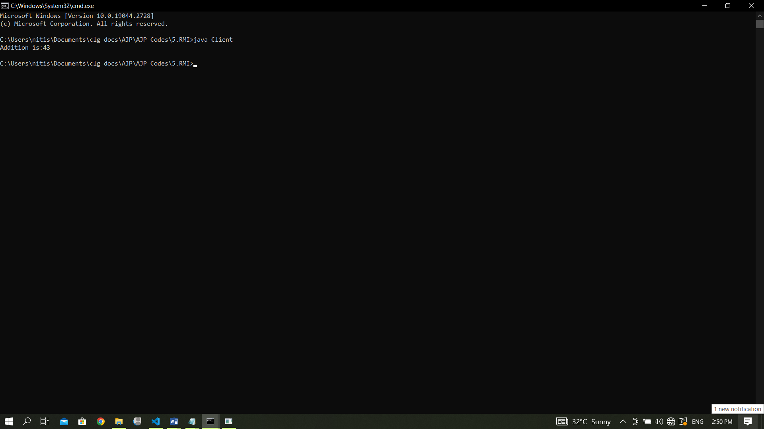

Program for Palindrome:

**1)one.java**

import java.rmi.*;  
interface one extends Remote  
{  
  
    public int palin(String a) throws RemoteException;  
}

**2)two.java**

import java.rmi.*;  
import java.lang.*;  
import java.rmi.server.*;  
public class two extends UnicastRemoteObject implements one  
{  
    public two() throws RemoteException { }  
    public int palin(String a) throws RemoteException  
    {  
        System.out.println("Hello");  
        StringBuffer str = new StringBuffer(a);  
        String str1 = str.toString();  
        System.out.println("Print : " + str1.toString());  
        StringBuffer str2 = str.reverse();  
        System.out.println("Print : " + str2.toString());  
        int b = str1.compareTo(str2.toString());  
        System.out.println("Print : " + b);  
        if (b == 0)  
            return 1;  
        else  
            return 0;  
    }  
}

**3)rmiserver.java**

import java.io.*;  
import java.rmi.*;  
import java.net.*;  
public class rmiserver  
{  
    public static void main(String args[]) throws Exception  
    {  
        try  
        {  
            two twox = new two();  
            Naming.bind("palin", twox);  
            System.out.println("Object registered");  
        }  
        catch(Exception e)  
        {  
            System.out.println("Exception" + e);  
        }  
    }  
}

**3)rmicleint.java**

import java.io.*;  
import java.rmi.*;  
import java.net.*;  
public class rmiclient  
{  
    public static void main(String args[]) throws Exception  
    {  
        try  
        {  
            String s1 = "rmi://localhost/palin";  
            one onex = (one)Naming.lookup(s1);  
            int m = onex.palin("madam");  
            System.out.println("Print : " + m);  
            if (m == 1)  
            {  
                System.out.println("The given string is a Palindrome");  
            }  
            else  
            {  
                System.out.println("The given string is not a Palindrome");  
            }  
        }  
        catch (Exception e)  
        {  
            System.out.println("Exception" + e);  
       }

}

